Project Design Phase-II
Technology Stack (Architecture & Stack)

Date | 25 September 2026
Team ID | SWTID-2026-7212
Project Name | AI StudyBuddy
Maximum Marks | 4 Marks

Technical Architecture:
The Deliverable shall include the architectural diagram as below and the information as per the table1 & table 2
AI StudyBuddy – AI-Powered Educational Backend Architecture
Reference: Project source code and README supplied for AI StudyBuddy
Guidelines:
Include all the processes (As an application logic / Technology Block)
Provide infrastructural demarcation (Local / Cloud)
Indicate external interfaces (third party API’s etc.)
Indicate Data Storage components / services
Indicate interface to machine learning models (if applicable)


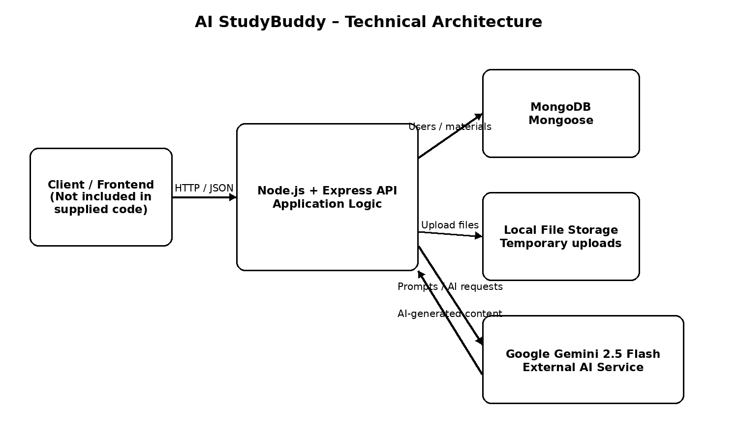
Technical Architecture Diagram – AI StudyBuddy
Table-1 : Components & Technologies:
S.No | Component | Description | Technology
1 | User Interface | The supplied project is a backend API. A client/frontend can interact with the REST API using HTTP/JSON; no frontend code is included in the supplied source. | REST API endpoints; JSON; HTTP/CORS
2 | Application Logic-1 | Authentication and authorization: registration, login, token refresh, logout, JWT verification, and student/admin role control. | Node.js, Express.js, jsonwebtoken, bcryptjs
3 | Application Logic-2 | Study-material management: upload, read, list, and delete study materials, with file validation and temporary local storage. | Node.js, Express.js, Multer, fs/path
4 | Application Logic-3 | AI-powered study functions: summary, flashcards, MCQ quiz, and personalized study plan generation. | Google Generative AI SDK, Gemini 2.5 Flash
5 | Database | Stores User and Material documents, including user details, uploaded material content, summaries, flashcards, quizzes, and study plans. | MongoDB with Mongoose ODM
6 | Cloud Database | No cloud database configuration is specified in the supplied project. The environment uses a configurable MONGO_URI. | MongoDB; deployment location depends on MONGO_URI
7 | File Storage | Uploaded .txt, .md, and .pdf files are temporarily stored in the local uploads/ directory, read by the server, and then removed after the content is saved to MongoDB. | Local filesystem; Multer diskStorage
8 | External API-1 | Generates AI responses for summarization, flashcards, quizzes, and study plans. | Google Gemini API via @google/generative-ai
9 | External API-2 | No second external API is implemented in the supplied source code. | Not applicable
10 | Machine Learning Model | Generative AI model used to transform uploaded study material into summaries, flashcards, quizzes, and study plans. | Google Gemini 2.5 Flash
11 | Infrastructure (Server / Cloud) | The supplied project runs as a Node.js server on a configurable port (default 5000). No specific cloud deployment, load balancer, Kubernetes cluster, or cloud server configuration is supplied. | Node.js runtime; Express server; local/development deployment

Table-2: Application Characteristics:
S.No | Characteristics | Description | Technology
1 | Open-Source Frameworks | The project uses open-source Node.js packages for the API server, database access, authentication, file upload, CORS, environment configuration, and error handling. | Node.js, Express.js, Mongoose, Multer, bcryptjs, jsonwebtoken, cors, dotenv, express-async-errors
2 | Security Implementations | Passwords are hashed before saving; JWT access and refresh tokens are used; protected routes verify the access token; admin routes require the admin role; uploaded files are restricted by extension and 5 MB size. | bcryptjs; JSON Web Tokens; role-based access control; Multer file filter/limit; CORS
3 | Scalable Architecture | The current implementation is a modular Node.js/Express API with separate routes, controllers, middleware, models, and utilities. It is not implemented as microservices in the supplied code. | Node.js + Express.js modular architecture; MongoDB/Mongoose
4 | Availability | The supplied project does not implement load balancing, distributed servers, failover, or a high-availability cloud setup. Availability therefore depends on the server and MongoDB deployment used. | Express server; MongoDB; deployment configuration
5 | Performance | The API uses asynchronous request handling and database operations. Uploaded files are limited to 5 MB and temporary files are removed after their content is read. MongoDB provides a unique index for user email through the schema. | Node.js async/await; MongoDB/Mongoose; Multer limits; unique email index

